BARPAK – ONE YEAR AFTER THE GORKHA EARTHQUAKE

I visited Barpak at the weekend to look at the state of the village one year on from last year’s earthquakes. Given its proximity to the epicentre of the 25 April 2015 Gorkha Earthquake, Barpak suffered considerable damage and 12 villagers were killed with many more seriously injured. With the first anniversary just a few days away, and following the scrutiny the town came under in the immediate aftermath last year, 6GRRA will be interested to learn what the Gurkha Welfare Scheme is doing there and, in particular, how we are helping seven 6GR pensioners whose homes were destroyed.

A 3½ hour drive from Gorkha, the town is unique in that its population lives in a tightly packed area straddling the ridge in approximately 1500 houses. The initial overall impression is of corrugated iron and tarpaulins and closer inspection reveals little by way of reconstruction. The exception to this is the work being undertaken by the Gurkha Welfare Scheme (GWS) and a handful of small businesses (shops and guesthouses) which are being rebuilt. Most of the population is living in temporary (generally CGI) shelters, some of which are assuming an impression of semi-permanence. During our visit we stayed in a CGI/plywood guesthouse built on donated land; this is a new business where previously no visitor accommodation existed.

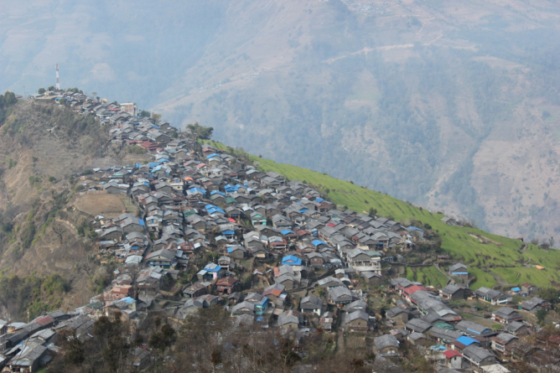 | 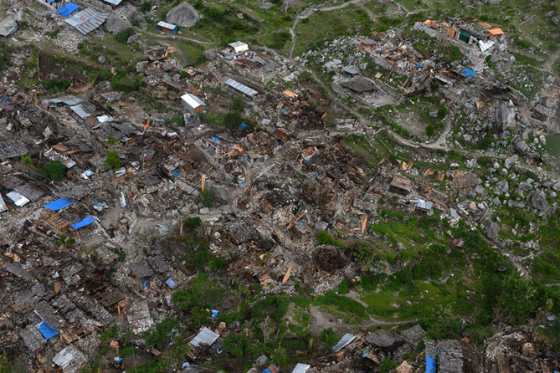
Barpak before the earthquake… | …and immediately after

The GWS is rebuilding 26 pensioners’ homes in Barpak; seven of these are 6GR widows whose husbands are listed below:

6267 LNk Bhatti Lal Gurung 6GR
831 Rfn Mar Sing Gurung 6GR
21151876 Rfn Budhi Bahadur Gurung 2/6GR
21134119 Man Bahadur Ghale 1/6GR
21145527 CSgt Lalman Gurung 2/6GR
21148296 Rfn Dalaram Ghale 6GR
21148298 LCpl Sher Bahadur Gurung 1/6GR

Manbahadur Ghale was killed in the earthquake as were the daughter-in-law and great granddaughter of Rfn Marsing Gurung whose widow, Man Mati, now lives with her son and whose house we are rebuilding. The first few houses are likely to be completed by the end of the month; the remainder will be occupied by June. Close supervision of the builds by AWO Gorkha and a near permanent presence by a project supervisor we have hired as our ‘Barpak Manager’ is ensuring that the standard of construction is among the best we have seen across the country. Teams of tradesmen are being employed by house owners in local clusters, alternating between sites to maintain activity on one while concrete cures on another.

We are also partnering with a local NGO to install smokeless cookers in all our houses, thereby mitigating one of the main contributory factors to cataracts and respiratory diseases, and using the NGO’s capacity to provide training in building stoves for others as well.

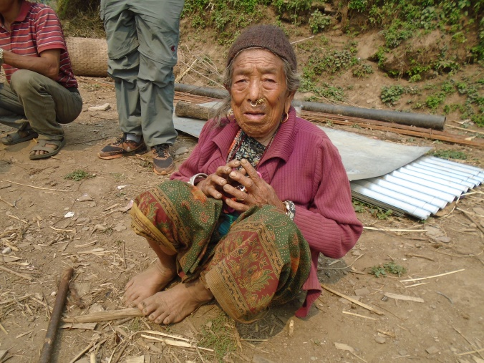 | 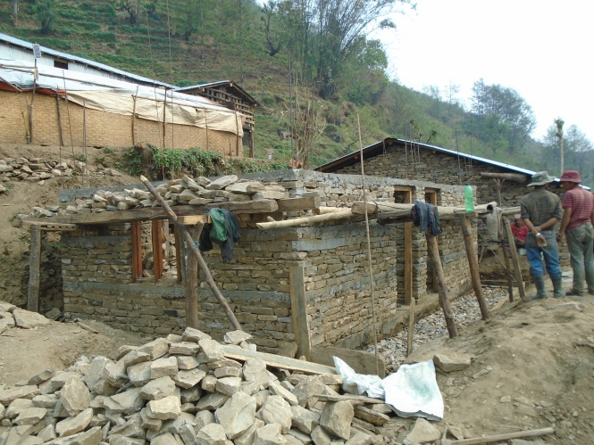
Bal Maya Gurung, widow of LNk Bhatti Lal Gurung, and her new home under construction

We now have just under 500 houses being reconstructed across the country, about 40% of our total. While Gorkha district was hit worst (over 300 of our builds are there and many more houses need to be repaired) there is barely a district from mid-West to Eastern Nepal which is unaffected. Our welfare officers are constantly out in their areas, reassessing the need, supervising repairs and reconstruction and the presence of a GWS vehicle, motorbike (or, in my case, the badge on my GWS topi) does reassure people that they have not been forgotten.

On top of this, thanks to the incredible generosity of major donors, we have increased our schools rebuilding programme this year. As a result, seven new schools in the earthquake affected districts will be completed by the end of July…we will then break ground on a further 10 in November.

Finally, I cannot resist a word about that fine body of men, the Queen’s Gurkha Engineers. 69 Gurkha Fd Sqn is now mid-way through Op MARMAT 3, supervising the build of almost 40 houses up in Ramechhap district. Taking a great chunk out of AWO Jiri’s ‘bill’ to rebuild over 200 houses, the Squadron has deployed troops to the villages of Bhuji and Rasnalu where it’s like Barratt Homes on steroids! The first is likely to be completed by the time most of you reach the bottom of the page.

6GRRA has been incredibly generous in raising money for the rebuilds and a number of the houses in Barpak will be attributed to the donations the Association has given. Please continue to follow the updates published by the GWT on www.gwt.org.uk and, with each house costing just over £4,000, if you fancy raising a few extra bob to help us meet our target for rebuilding, contact our Director of Fundraising, Karen England on karenengland@gwt.org.uk or 01722 323955.

John White

Pokhara, 22 April 2016

